**Key Notes**

Here’s a quick explanation of **mean**, **median**, and **standard deviation**:

**Mean (Average):**

The mean is the sum of all values divided by the number of values. It represents the central value of a dataset.

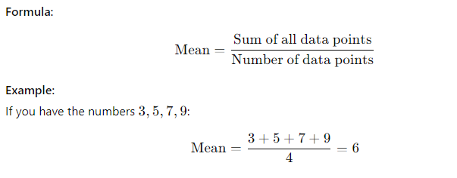

**Median:**

The median is the middle value of a dataset when the numbers are arranged in order. If the dataset has an even number of values, the median is the average of the two middle values.

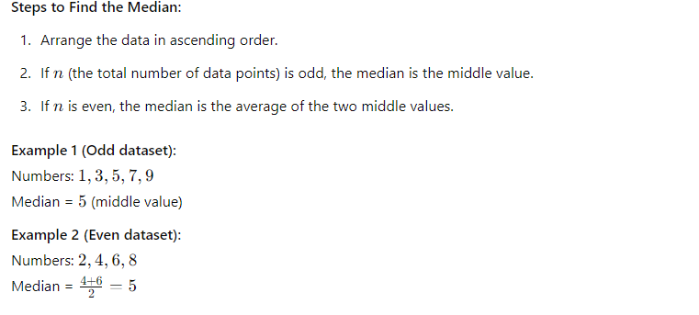

**Standard Deviation:**

The standard deviation measures how spread out the numbers in a dataset are from the mean. A low standard deviation means the values are close to the mean, while a high standard deviation

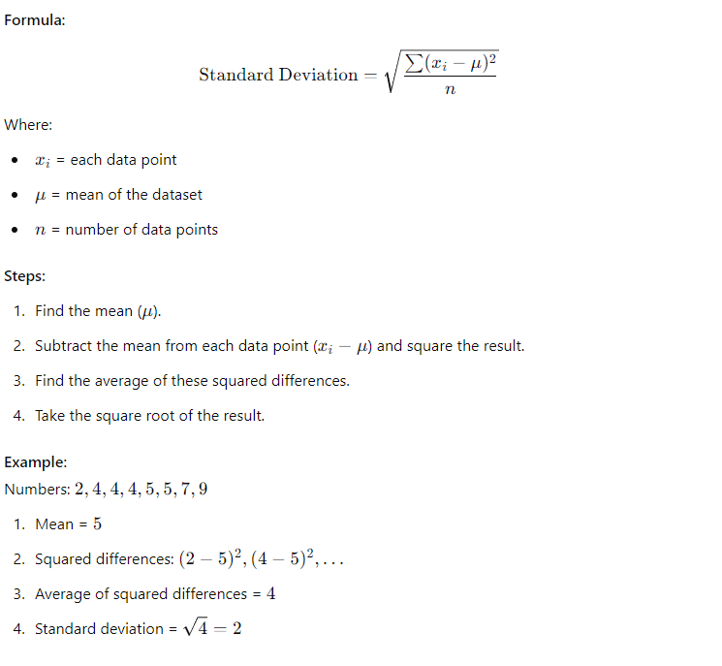

**Mode:**

The **mode** is the value (or values) that appears most frequently in a dataset. It represents the number(s) that occur the highest number of times.

**Key Points About the Mode:**

1. A dataset may have:
   * **No mode** (if all values occur only once).
   * **One mode** (unimodal) if one value occurs most frequently.
   * **Two modes** (bimodal) if two values tie for the most frequent occurrence.
   * **More than two modes** (multimodal) if multiple values occur with the same highest frequency.
2. The mode is not affected by extreme values (outliers).

**Example:**

1. Dataset: 1,2,3,3,4,5,51, 2, 3, 3, 4, 5, 5
   * Modes: 33 and 55 (bimodal, as both appear twice).
2. Dataset: 2,4,6,8,102, 4, 6, 8, 10
   * Mode: None (all numbers occur only once).
3. Dataset: 3,3,3,5,7,93, 3, 3, 5, 7, 9
   * Mode: 33 (occurs three times, more than any other number).